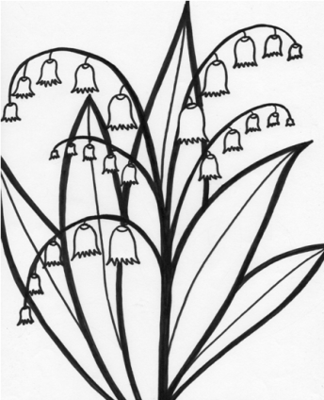
Native Plants

With the help of the King Conservation District, we removed blackberries from the farm, and planted Native plants. Native plants are plants that naturally grow in the area. Native plants grow stronger and get less sick than non-native plants.

Native Animals

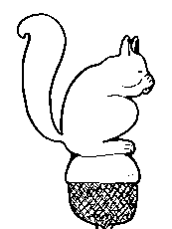
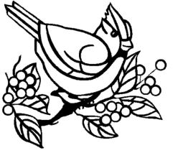
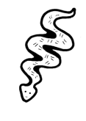

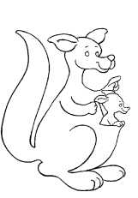
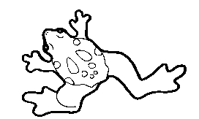

Circle the one that is not a native animal

Planting Native plants has allowed and welcomed more native animals. There are more birds, fish, bees, frogs, and other animals that have made homes on the farm. The native plants have provided shelter, food, and protection for these animals.

